After the usual survey the course starts in Module 2 with an introduction to cloud computing as the on-demand delivery of IT resources over the internet with pay as you go pricing. AWS leads cloud computing to working with large and small companies. It grew at a rapid pace starting the early 2000s, with the advantages of being able to focus on the most important factors, giving flexibility without commitment that non-cloud services require. Different models and strategies provide differing control and management. Models include infrastructure as a service, platform as a service, and software as a service. The strategies that can be employed include choosing between cloud, hybrid, or on-premises deployment.
Module 3 goes over AWS itself including its benefits such as on demand access of over 175 services, pay as you go pricing, and no upfront commitments. It has become the leading cloud computing vendors placing highest in both abilities to execute and completeness of vision. The main components of AWS’ infrastructure are the regions, availability zones, and edge locations. Availability zones are good for planning for failure as data is stored in every availability zone in a region, so if one fails then the data is not lost. It can also be planned on a global level by having backups in another region. Other benefits of the infrastructure include performance, availability, security, reliability, scalability, and low cost. The AWS well architected framework is built on several pillars including operational excellence, security, reliability, performance efficiency, cost optimization, and sustainability. AWS also has a metric called TCO to give an accurate report and comparison for AWS services, having pay-as-you-go, save when you reserve, and pay less by using more models to choose from. There is also free tier offers providing no cost services.
Module 4 involved a rundown of followed by several tutorial videos that covered the following services:
- Creating s3 buckets, how to upload files into them with various methods, viewing files by their file url, changing permissions by policies
- Set up ec2 linux server instances, creating a keypair for the ec2, configure network settings alongside custom vpc, and view launched instances
- Create a custom vpc and deploy an ec2 instance into it
- Create and configure an RDS database
- Create IAM users and user groups, and configure the permissions and policies users and groups have access to (this includes testing if the user can perform the actions)
- Create an AWS lambda function using a blueprint and add a trigger to it
- Create an alarm in CloudWatch, such as a billing alarm that notifies via email when a certain amount of money is spent or a CPU threshold being met, and monitor the status of the alarm
Module 5 covered cloud-based careers due to their demand and high benefits. Different qualifications are required based on the role, and basic career pathways to pursue. Due to the wide variety cloud-based careers have high mobilities allowing for different types of jobs to be both an entry and transitioning point.
Afterwards there was a final assessment
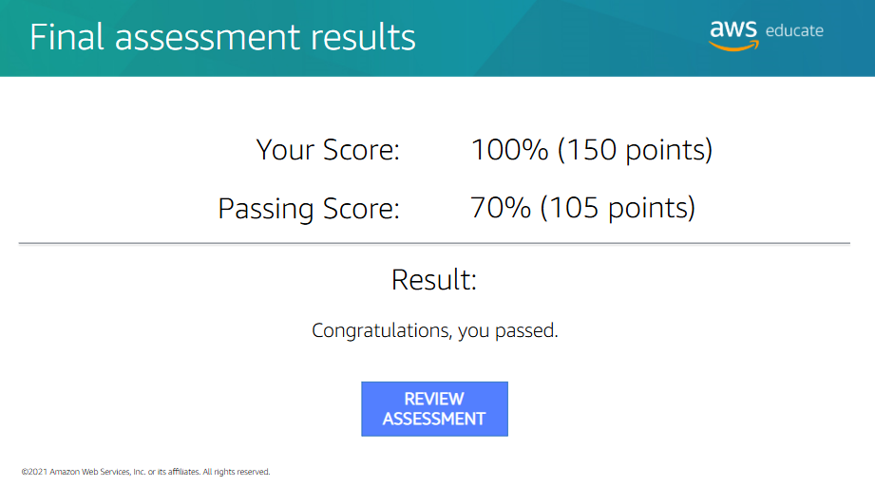
The ends with providing next steps to take for training and certifications and the typical ending survey.
